***8***

**BMZ NARRATIVE Bi-Annual REPORT**

**Christoffel-Blindenmission Deutschland e.V.**

**Project Details**

|  |  |
| --- | --- |
| Project Number: | 4014-BMZ-MYP |
| Project Title: | Prevention of childhood hearing impairment through enhancing and strengthening ENT services in Zimbabwe. |
| City/ Country /Region: | Zimbabwe |

|  |  |
| --- | --- |
| Name of Contractual Partner: | WizEar Trust |
| Other Implementing Partners: | Ministry of Health and Child Care (MoHCC) |

|  |  |
| --- | --- |
| Duration of Project: | 40 months |
| Project Start Date: | 01.09.2020 |
| Project End Date: | 31.12.2023 |

|  |  |
| --- | --- |
| Report Submitted by: | WizEar Trust |
| Name: | Lucia Nkomo |
| Designation: | Program Manager |
| Email Address: | [luciankomo@wizear.org](mailto:luciankomo@wizear.org) |

|  |  |
| --- | --- |
| Reporting Period: | January 2022- December 2022 |
| Date of Submission: | 13 December 2022 |

1. **General Information**
   1. **Project Short Description / Project Goal**

The P4014 comes up as a scale up project to a successfully completed BMZ/CBM P3214 project, which started in 2015. The aim of the project is primarily to build on the previous project and further strengthen the quality of ENT services in Zimbabwe. The goal is to improve the quality of life of the population group affected by hearing impairment especially children, the elderly and those with other disabilities through the reduction in prevalence rate of hearing impairment. Through the use of three strategic pillars, WizEar endeavours to make sure that people with hearing impairment’s risk of poverty has decreased through reducing the consequences of disability. This will be achieved through the following measures.

1. Expansion of the existing ENT services at Sally Mugabe Children’s Hospital formerly known as Harare Children Hospital by creating a separate operating theatre and reintroducing speech therapy.
2. Strengthening ENT services in 8 provinces of Zimbabwe by empowering medical staff at provincial and district hospitals
3. Strengthening of decentralized services and referral system by empowering community health workers
4. Lobbying the governmental agencies for the implementation and budgeting of the national ENT strategy.
   1. **Sources of Information (10 lines)**

The source of information for this report was collected from ENT statistics gathered from central, provincial and district hospitals under the P4014 ENT project. Information was also collected from government stakeholders and ministries, these include Ministry of Health and Child Care and Ministry of Public Service, Labour, and Social Welfare. Clients who received ENT services were also interviewed as part of the feedback method. Some of the needed information was collected through monitoring visits. Statistical data collection was collected on monthly basis from all the hospitals under the P4014 ENT project. For this year a considerable number of clients was obtained from ear camps, medical outreaches and community awareness activities.

1. **Status of Implementation of the project**

*The impact matrix reflects a current-status in every bi-/annual report*

*All data should be disaggregated (women, men, girls and boys, person with disabilities, no duplications please), if possible.*

|  |
| --- |
| **Overall objective (impact): Contribution to sustainable ENT medical care in Zimbabwe** |

|  |  |  |  |  |  |
| --- | --- | --- | --- | --- | --- |
| **Specific Objective** | **Indicators** | | | | |
| Target | Achievement only in current reporting period in numbers  (quantitative & qualitative) | Achievement in previous reporting period in numbers  (as stated in previous report) | Total accumulated achievement up-to-date (cumulative) | Description of achievement so far. Explanation for over-achievement or underachievement of the indicators. |
| Prevention, diagnosis, treatment, and rehabilitation of hearing impairment in the target region have improved and are accessed by more people | Overall, 28,650 people treated, and 986 people trained during the project period | 8.768 adults treated (3.865 males, 4.903 females)  9.817 Children were treated, 5.124 boys and 4.693 girls  357 people trained, 83 males and 274 females | From January to December 2021 a total of 1.672 adults were treated of hearing problems. There were 804 males and 868 Females  844 Children were treated, 430 boys and 414 girls  138 people trained, 61 males and 77 females | Cumulatively 21.200 people were treated from September 2020 to December 2022  Of the 10.539 Adults treated 4.714 were males and 5.825 were females  Of the 10.661 Children treated, 5.554 were boys and 5.107 were girls  521 people trained, 151 males and 370 females | An increase in secondary and primary capacity building measures were one of the drivers for the increase in statistics. Having more people with service delivery knowledge resulted in more people reached and assisted. Introduction of new service centres within districts also helped in boosting the numbers. Trained personnel coupled with service delivery and awareness raising was a working strategy for increase in numbers. |
| ENT services are part of the national health system and sustainably guaranteed | After considerable engagement with the Ministry of Health and Child Care it was unanimously agreed that a team from both WizEar and MoHCC should conduct a 5-day workshop for the review and finalisation of the National Ear and Hearing Strategy. Feedback on reviewing of the National Ear and Hearing Strategy was supposed to take place in Q3. All groundwork and expected participant list were in place. Chief amongst participants were the Steering Committee and PWDs, however this failed due to insufficient funds. | While all necessary groundwork and planning for the review was done. Late and non-disbursement of funds derailed the entire process. Without the necessary funding for the activity, it was not easy to plan especially with third parties like the MoHCC who had other pressing engagements as well. | P4014 ear and hearing Steering Committee is leading engagements with the MoHCC to have the strategy timelines reviewed. Progress update was supposed to be provided in the Q3 Steering Committee meeting. As a result of late disbursement of funds, the Stakeholder and Steering Committee meeting failed to take place. | Strategy review is a process which must be done by the MoHCC and WizEar is only lobbying for the review of the document, but the actual review is determined by MoHCC. MoHCC agreed to review the document and dates for stakeholder meetings were set by the MoHCC so that every stakeholder involved in the ENT could review the document. However, this failed to take place due to late disbursement of funds. Once normal implementation has resumed, this activity will be conducted. |

**To reach the Overall and specific Objective, the project aims to reach 4 Results, each equipped with indicators:**

|  |  |  |  |  |  |  |
| --- | --- | --- | --- | --- | --- | --- |
| **Results** (Output) | **Indicators** | | | | | |
| Target | Achievement only in current reporting period in numbers  (quantitative & qualitative)  *usually for 6 months)* | Achievement in previous reporting period in numbers  (as stated in previous report) | Total accumulated achievement up-to-date (cumulative) | Description of achievement so far. Explanation for over-achievement or underachievement of the indicators. |
| 1. Access to and quality of ENT, audiology and speech therapy services in Harare is improved | An operating theatre built and equipped | The paediatric ENT Theatre is now fully operational although there are some minor glitches. While all the major equipment is now in place there is need to provide theatre with consumables which include analgesics, anxiolytics’, sevoflurane, desflurane, isoflurane, ketamine and etomidate. Use of the theatre commenced in October. This therefore shows that the equipment is fully functioning  Technical and Structural handover of the theatre to Ministry of Local Government and Public Works was held. Public Works Engineers overall review was satisfactory and thus a certificate of completion was produced. | Paediatric ENT Theatre construction at Sally Mugabe Children’s Hospital overall progress is now at 98 percent near completion. The contractor managed to complete roofing, roof ceiling, plumbing. Theatre construction final touch ups to be completed after theatre equipment has been installed, these include theatre lights, medical gases, and aluminium doors to the main entrance of the paediatric ENT theatre which are being fixed. | Sally Mugabe ENT paediatric theatre completed and is in use | The theatre is now fully operational. Theatre operations are successfully being conducted in the newly finished ENT Theatre. Technical and structural handover of Paediatric ENT theatre at Sally Mugabe was done. The theatre was handed over to Sally Mugabe Hospital and Ministry of Local Government and Public Works. Ministry of Local Government and Public Works signed certificate of completion. All theatre equipment has been installed in the theatre and a theatre trial run was conducted and it was successful. The official opening will be officiated by MoHCC. It was rescheduled to Q1 2023. |
| Increase in surgeries to 1,200/year | 1.227 surgeries were performed, 637 boys and 590 girls | A cumulative total of 192 paediatric patients managed to go under surgeries from September 2020-December 2021. 98 are boys and 94 are girls | Cumulatively 1.419 ENT surgeries performed, 735 are boys, 684 are girls. | The completion of the ENT theatre at Sally Mugabe Hospital has significantly increased the number of surgeries at the hospital. Further implementation of an ENT paediatrics surgery camp as well as other referees from our normal ear camps, have managed to boost the number of surgeries for this year. Inclusion of Parirenyatwa Central Hospital data from adult ENT clinic, also boosted the numbers. They were also referees from provincial hospitals. |
| Increase in number of examinations / years:  audiology: 400  speech therapy: 100 | At HCH:  7.823 patients were examined for audiology cases (1.003 males, 1.278 females, 2.741 boys, 2.801 girls)  277 children (149 boys and 128 girls) were examined for speech therapy sessions.  Total through all med. Facilitations:  10.296 patients were examined for audiology cases (1.849 males, 2.185 females, 3.108 boys, 3.154 girls)  277 children (149 boys and 128 girls) were examined for speech therapy sessions. | At HCH:  703 patients were examined for audiology cases (142 males, 158 females, 203 boys, 200 girls)  64 children (33 boys and 31 girls) were recommended for speech therapy sessions.  Total through all med. Facilitations:  From January to December 2021, a total of 1.076 patients were examined for audiology and chief amongst cases seen were foreign body removals and middle ear infections (331 males, 342 females, 203 boys, 200 girls).  64 children (33 boys and 31 girls) were recommended for speech therapy sessions. | Cumulatively At HCH:  8.526 patients were examined for audiology cases (1.145 males, 1.436 females, 2.944 boys, 3.001 girls)  341 children (182 boys and 159 girls) were examined for speech therapy sessions.  Cumulative total through all med. Facilitations:  11.372 patients were examined for audiology cases (2.180 males, 2.527 females, 3.311 boys, 3.354 girls)  341 children (182 boys and 159 girls) were examined for speech therapy sessions. | The secondment of University of Zimbabwe Audiology students on attachment to government and public hospital has improved number of speech therapy services. Provision of hearing aids remain a major challenge for school going children whose demand for these exceed supply. |
| Increased capacity at Parirenyatwa Hospital/ year:  Examinations: 4.200  Audiology: 1.400 | 1.486 clients (745 males, 741 females) provided with ENT examinations.  558 clients (280 males, 278 females) underwent audiology assessments | From January to December 2021, 708 clients (331 males, 363 females, 8 boys, 6 girls) provided with ENT examinations.  373 clients (189 males, 184 females) underwent audiology assessments  27 adults (16 females and 11 males) were fitted with hearing aids. | 2.233 clients (1.093 males, 1.126 females, 8 boys, 6 girls) provided with ENT examinations.  931 clients (469 males, 462 females) underwent audiology assessments | An increase in the provision of Audiology assessments and ENT Examination at Parirenyatwa hospital is due to support with audiology equipment provided under the P4014 Project. ENT, and consumables that include audiometer and otoscopes were handed |
| A total of 3 paediatric ENT physicians trained  (Indicator was missing in previous reporting template – amended on 28.04.2022) | 2 ENT paediatric physician Dr Garwe and Dr Nzvenge are under fellowship. Dr Nzvenge is still being trained since January 2022. Dr Garwe recently joined the fellowship. To date 2 fellows are under the ENT Fellowship programme. | Dr Nzvenge enrolled under Fellowship in January 2022 after the completion of the curriculum development | Two paediatric ENT doctors undergoing training. The training relies on observation and the available theatres. Now that the ENT theatre is open, the target of 3 will be reached by end of 2023 | Although there was a delay, to date two paediatric ENT physician Dr Nzvenge and Dr Garwe are under the Reverse Fellowship training at Sally Mugabe hospital So far. Dr Garwe is now at 52 hours of her theatre hours. Dr Nzvenge has so far clocked in 188 hours of surgery which includes the complicated ones and the less complicated ones like tonsillectomy. The total number of hours is 220 hours |
| 2. The medical infrastructure for treating ear diseases on provincial and district level in the target region permanently improved | The following staff is qualified on provincial and district level:  -General practitioners: **8**  -Nurses & rehabilitation technicians: (provincial level): 46  (District level): 26 | 357 medical staff were trained in 2022:  19 Doctors (12 male, 7 female)  3 Nurses (1 male, 2 female)  0 RTs (province level)  2 RTs (district level; 1 male, 1 female)  300 VHW (51 males, 249 females)  33 med. Students (18 males, 15 females) | 138 medical staff were trained in 2021:  10 Doctors (6 male, 4 female)  49 Nurses (15 male, 34 female)  25 RTs (province level; 17 male, 8 female)  16 RTs (district level; 9 male, 7 female)  30 VHW (11 males, 19 females)  8 med. Students (3 males, 5 females) | Cumulatively, 521 medical staff were trained so far:  29 Doctors (18 male, 11 female)  72 Nurses (19 male, 53 female)  31 RTs (province level; 21 male, 10 female)  18 RTs (district level; 10 male, 8 female)  330 VHW (62 males, 268 females)  41 med. Students (21 males, 20 females) | Trainings of staff at central, provincial and district hospitals focused on basic ENT health. Refresher trainings failed to take place in 2022 due to insufficient funds. As a result of insufficient funds these refresher trainings will be conducted in the year 2023. |
| Provincial hospitals equipped with diagnostic equipment and consumables | 10 Audiometers and 10 Otoscopes distributed to 6 provincial and 4 central hospitals  Ear consumables that include 200/5mls of antibiotic eardrops and 20 litres of boric acid were also distributed to these 6 provincials and 4 central hospitals. | 3 Central hospitals and 6 Provincial Hospitals received Ear consumables that include 400/5mls of antibiotic eardrops and 20 litres of boric acid per hospital. | 10 Audiometers and 10 Otoscopes distributed to 6 provincial and 4 central hospitals  Ear consumables that include 200/5mls of antibiotic eardrops and 20 litres of boric acid were also distributed to these 6 provincials and 4 central hospitals. | Hospitals under the P4014 ENT project received consumables and equipment. 4 Central Hospitals and 6 Provincial Hospitals received a set of audiometers each and otoscopes. These hospitals also received ear and hearing consumables that are ear drops and boric acid. |
| Services are expanded to district level and district hospitals are equipped with diagnostic equipment and consumables | 13 District hospitals received medical consumables (100/5mls antibiotic ear drops) and a set of otoscopes | P4014 Ear and hearing Project expanded to cover 13 Districts which are Binga , Hwange , Beitbridge , Matobo , Insiza , Mberengwa , Gokwe North , Buhera, Chipinge, Zaka, Chiredzi, Mbire and Mazowe. Hospitals will also receive 2 otoscopes each and ear consumables that’s 100/5mls ear drops per year per hospital. | 13 district hospitals have been supported with ear and hearing health diagnostic equipment and consumables | All 13 District hospitals under P4014 Project now have set of otoscopes and they frequently receive ear and hearing health consumables that mainly include ear drops. |
| 3. An efficient referral system has been introduced and health services are connected | Efficient referral system established, and local organisations and health care providers strategically networked | Trainings of Village Health Workers (VHWs) were conducted during the year. These VHWs were trained during ear camps conducted by WizEar. As seen above, 300 VHWs were trained. Community awareness was raised through provision of brochures, fliers, pamphlets, and public addresses to the communities during the period, Wizear equally attended the ENT-Expo in responds to the mid-term evaluation´s recommendation which supported the strategic networking. | To create an efficient referral system between districts and provinces, ear camps were conducted across the country. Many clients are being referred to either WizEar or the trained institutions to provide ear and hearing health services. One such ear camp was conducted at Howard and Musami ear camps were conducted between the months of July to September 2021, Gweru Provincial Hospital from 26 to 28 November 2021 among other areas. | During ear camps and outreaches WizEar is training community health workers and paraprofessionals to provide basic information and services on ear and hearing health. Clients are being referred to hospitals by Community health workers. | So far, the referral pathway that is being used starts from Village Health Workers, who refers to Primary Health Facility Hospitals, District Hospital, Provincial Hospital. If the Provincial Hospital fails it will refer to Central Hospital. |
| A total of 30 outreaches carried out | During the year 2022 WizEar managed to conduct 21 outreaches, where 3.536 people (838 males, 1.147 females, 873 boys, 678 girls) were examined. | Between January and December 2021 WizEar team held 3 Outreach Ear Camps where 476 people (142 males, 163 females, 88 boys, 83 girls) were examined. | 24 outreaches and have been conducted to date, reaching 4.012 people (980 males, 1.310 females, 961 boys, 761 girls). | There is need to conduct monthly outreaches in 2023 so that we will be able to reach the targeted 30 outreaches by December 2023. To date 24 outreaches have been conducted out of a target of 30, this means that 6 outreaches need to be conducted. |
| A total of 900 Community Health Workers trained and integrated into ENT care | As seen above, 300 Village Health Workers have been trained during 2022. They were trained during ear camps, medical and community outreaches | Between January and December 2021, a total of 30 Village Health Workers were trained in basic ENT health services during ear camps. The Community Health Workers were trained in basic ear pathologies, hearing aid troubleshooting and making referrals | A cumulative total of 330 Village health workers have been trained to date | Trainings for Village Health Workers in 2021 were not feasible due to Covid-19 restrictions, however in 2022 budgetary constraints refrained the organisation from conducting more trainings for VHWs. Once implementation resumes, an acceleration plan to achieve the target will be considered. Elections are also coming in Q2 and may affect physical gatherings |
| The population is informed about the services and sensitised about ENT prevention by means of education campaigns. | The organisation attended a number of workshops by other partners, which was also a good platform for sharing the work that WizEar does. Such platforms feed in the overall referral system. | Lectures on ear and hearing health care were held during ear camps. This is a platform where trained community health workers share basic audiology information with members of public. Part of their job description includes offering services to the members of the public through referrals and basic screenings. | IEC messages were developed in partnership with OPDs, MoHCC and CBM. Prototypes of IEC material in the form of t-shirts, caps, pamphlets, and banners have been development and submitted to CBM for review  WizEar managed to sensitize members of the public through public addresses, radio broadcast, social media, and distribution of IEC materials with messages on ear and hearing health. | To ensure wider reach, awareness will continue to be raised through radio slots in 2023 and information packs were developed with detailed basic ear and hearing health content for distribution to clients and stakeholders |
| 4. The treatment of ear diseases is firmly anchored in the Zimbabwean health system | WizEar has an MoU with the Ministry of Health and Child Care (MoHCC). Through the National Strategy for Prevention of Hearing Impairment, the government department committed to availing posts for audiologists and speech therapists. | By 2022, 16 BSc. Audiology and Speech Therapy students graduated from the BSc. Honours in Audiology programs initiated by WizEar in 2018. This means the country now has 13 audiologists and 3 speech therapists who now will be absorbed in the government run hospitals. Although the students started out as 20, the other 4 failed to graduate due to poor academic results. This boost in workforce will result in an increase of numbers of people to be served. Currently, discussions on government freeing up posts is still underway, but some of the audiologists have already been absorbed. | WizEar worked with the Ministry of Health and Child Care, Rehabilitation Department and Policy Planning Department in pushing for review of the ENT Strategy so that it can be incorporated in the National Health Systems. The strategy mandates the government to create audiology and speech therapy post in all hospitals. | Cumulatively, the country now has 26 audiologists and speech therapists, 5 of whom are speech therapists and 21 are audiologists. Of this total number, 16 are the new graduates, while 10 are the existing practitioners. This is a 62% increment in qualified service providers in audiology and speech therapy. | A 5-day workshop will be conducted to review and finalise the existing strategy document in a bid to extend its tenure. The meeting is expected to be conducted in the 1st quarter of 2023. |

**2.1 Further Explanations for Changes and adaptions in initial project plan**

1. **Activity 1.1: Construction of paediatric ENT operating theatres**

Theatre construction has been completed and the theatre is now fully functional. Technical handover of the theatre was done on the 9th of September 2022. Ministry of Local Government and Public Works Engineers managed to assess all structural, electrical, and mechanical fittings done on the theatre and they were certified that they meet the required government standards. After this careful deliberation, a Certificate of Completion was issued. The official opening will be officiated by the MoHCC and the date will be advised.

1. **Activity 1.6 Participation in National and Regional ENT Conferences**

Instead of funding the transportation and accommodation of 2 WizEar staff, the organisation supported an ENT conference which was conducted in Harare and was attended by ENT doctors undergoing the Reverse Fellowship program, BSc Audiology students and WizEar staff. WizEar supported the conference by paying for the conference venue and meals. A budget realignment was sought and approved.

1. **Activity 2.3: Procurement of Diagnostic Equipment and Consumables**

Ear and hearing equipment and consumables were procured for 4 Central and 6 Provincial hospitals. These are a set of an audiometer, 400/5mils ear drops and 20 litres of boric acid were procured to support the project. A set of otoscopes and 100/5mils ear drops were given to district hospitals

1. **Activity 4.2: Steering Committee meetings**

In Q1 and Q2 2022 two steering committee meetings were conducted. However, for Quarter 3 and 4 these meetings were shelved due to lack of funding. Once normal implementation resumes, activity will be conducted.

1. **Justification On Over-Procurement of Equipment and Consumables**
2. Demand: As the trainings and outreaches could not be done consecutively as planed due to the Covid-19 backlog from last year, they now needed to train and send the teams out at the same time. This increased the quantity of the medical equipment needed accordingly.
3. The additional training for district hospital nurses and Rehab-techs also helped to widen the span of influence. More people were then consulted on. This increased the numbers as well as the need for eardrops and anti-biotics.
4. Other cross-sectional diseases like TB, HIV and COVID-19 also boosted the numbers of people needing ear and hearing health. I.e. most of the TB patients had active suppurative middle ear infection which required anti-biotics and eardrops.
5. Ear-camps also contributed to an increase in procurement of consumables. Last year we had more ear-camps than in any other year and these also contributed to an increase in the budget.

**a. Status of implementation of activities, in comparison to proposal**

This is the main part of the report, where the focus is on the progress of the project implementation for the reporting year. Here we give detailed description of all implemented activities in the reporting period with photos, breakdown of target group reached per activities (women, men, girls and boys, person with disabilities, no duplications please). Hereby, we follow the structure of the proposal, describing each activity under each result.

If one of the results or activities have not been achieved/implemented although they were planned to be implemented in the reporting period, please describe the reason for delays, variations, challenges, obstacles and how you have or will scope them.

**Result 1:**

**The access and quality of ENT, audiology and speech therapy services in Harare is improved.**

**Activity 1.1: Construction of paediatric ENT operating theatres**

The Paediatric ENT theatres at Sally Mugabe are now fully functional. Theatre construction at Sally Mugabe Children’s hospital was completed. Structural and technical handover of the theatre to the hospital was held on the 9th of September 2022. Ministry of Local Government and Public works Engineers agreed that the structural, mechanical, and electrical fittings on the theatre are above the expected standard, and they meet government standards. Ministry of Local Government and Public Works released a certificate of completion.

**Activity 1.2: Equipment with specialised ENT devices and office equipment**

This is a list of specialised equipment procured during the annual year 2022. 1 x Diathermy machine, 2 x large dressing trolleys, 3 x Laryngoscope sets, 1 x Endoscopic telepak with video monitoring system, 2 x Tracheostomy Set, 2 x Micro Ear Set. The machines were installed at Sally Mugabe Paediatric ENT Unit.

**Activity 1.3: Equipment with medical consumables**

**Activity 1.4: Strengthening ENT services at Parirenyatwa Hospital.**

ENT services at Parirenyatwa Central hospital has since greatly improved since they received equipment and consumables to use. Parirenyatwa has 4 ENT specialists and one rehabilitation personnel who man the ENT Unit. The hospital received equipment comprising of an audiometer and an otoscope as well as consumables i.e. 400/5mls antibiotic eardrops and 20 liters of boric acid. The ENT Unit is also part of the training school for student doctors, junior doctors, and registrars

**Activity 1.5: Paediatric Fellowship Training Programme**

Although there was a delay in starting the ENT Fellowship program, to date, two paediatric ENT Surgeons Dr R. Nzvenge and Dr C. Garwe are under the Reverse Fellowship training at Sally Mugabe hospital. Fellows are expected to have completed a total of 220 hours within a year. Dr Garwe is now at 52 hours of her theatre hours. Dr Nzvenge has so far clocked in 188 hours of surgery. Consumables for Sally Mugabe ENT theatre were procured so that the medical staff are better placed to do their work and it also worked as a morale booster for them. Within the 3rd quarter of the year, 3 Mayo Doctors managed to come to support the fellowship project at Sally Mugabe Children’s Hospital. These were Dr Kate, Dr Wildermen and Dr Dontre.

**Activity 1.6: Increasing capacity of Project partners.**

An ENT conference was held in Zimbabwe in Q1 which WizEar supported. However due to lack of funds, WizEar staff failed to participate in another ENT capacity building workshop which took place in Capetown South Africa in Q3.

**Result 2:**

**The medical infrastructure for treating ear diseases on provincial and district level in the target region permanently improved**

**Activity 2.1: Measures for Capacity-building on Provincial Level (Secondary Healthcare)**

Capacity building training on provincial level during the period under review was not conducted due to lack of funds. Refresher training will be conducted in 2023.

**Activity 2.2: Capacity-building measures at district level (primary health care)**

During this period capacity building measures at district level were not conducted due to lack of funds. The activity will be conducted once normal implementation resumes.

**Activity 2.3: Procurement of Diagnostic Equipment and Consumables**

WizEar managed to distribute ear and hearing equipment and consumables to district, provincial and central hospitals under the P4014 Project. 13 district hospitals received an otoscope and 100/5mls ear drops each. 4 central hospitals and 6 provincial hospitals received audiometer, otoscope, 20 liters boric acid and 400/5mls of antibiotic ear drops each respectively

**Result 3:**

**An efficient referral system has been introduced and health services network**

**Activity 3.1: Networking on District Level:**

In 2022 WizEar carried 13 district networking activities in all districts under the project.

**Activity 3.2: Introduction of outreaches and referral system**

During this period 9 outreach 3 hearing aid fitting camps were conducted. This brings the total number of outreaches conducted in 2022 to 12. 19 outreaches out of a target of 30 has been conducted so far. More outreaches will be conducted in 2023 to try and speed up meeting the target of 30 outreaches as per the project plan.

**Activity 3.3: Inception Meetings District Level**

Inception meetings were finalised in quarter 2 of 2020 at the start of the project.

**Activity 3.4: Acquisition of project vehicle**

Vehicle procurement was finalised in Quarter 2 2020.

**Activity 3.4: Publicity and Awareness Campaigns**

The organisation hosted World Hearing Day on the 3RD of March 2022 where stakeholders from various institutions attended. The guest of honour was Dr Chimusoro from WHO. WizEar attended the 2022 Disability Expo that was held in Marondera, where it showcased all its services and activities. In total 217 people came for information and all services at WizEar information tent. WizEar managed to commemorate International Week of the Deaf Persons, which was held in September. The International Day of Sign Language was commemorated parallel to the IWDP celebrations. IEC materials with deaf messages and video skits with deaf stories were shared. Campaigns were conducted at the WizEar offices, during the outreaches and hearing aid fitting camps where the public was educated on ear and hearing health care. Most of the activities can be found on WizEar Social Media Platforms

**Result 4:**

**The treatment of ear diseases is firmly anchored in the Zimbabwean health system.**

**Activity 4.1: Kick-off workshop**

Kick-off workshop was finalised in Quarter 2 2020.

**Activity 4.2: Steering Committee meetings**

Only 2 Steering Committee meetings were held in 2022. Other 2 remaining meetings were not held due to lack of funds. Activity will be done in Q1 2023 after implementation resumes.

**2.2 Cooperation with other actors in the reporting period (beyond project partners)**

WizEar managed to cooperate with government stakeholders, NGOs partners and other OPDs in project implementation to ensure the active participation and meaningful involvement of these actors in ear and hearing health. WizEar successfully participated in the National Disability Expo that was held in Marondera. Other partnerships of worth are Jairosi Jiri Association, World Vision, Masawara Medical Outreach Programme, Ruwa Rehabilitation Centre and Pathways in providing ear and hearing services to OVCs in Mazowe District.

**2.3 Activities planned in following period:**

1. **Reverse Fellowship Programme**

The Reverse Fellowship has 2 fellows being trained currently with the 3rd one to join as soon as the first fellow completes the required 200 hours.

1. **Steering committee meetings**

P4014 Steering committee meeting will be held in 2023. The steering committee comprises of officials from Ministry of Health and Child Care, OPDs and other stakeholders in ENT health.

1. **Refresher Trainings**

Refresher trainings for provincial and central hospitals will be conducted in 2023

1. **Production of IEC information packs and radio broadcasts for awareness raising**

The awareness campaign ran through several channels in 2022. Social media, local radio and TV spots were regularly used to raise awareness. There was also an awareness event for World Hearing Day, which was covered on national television. In the outreaches, the first day was mainly used for awareness raising through role-playing, which was led by the VHWs. In addition, Wizear used it´s networking with OPDs, which was particularly promoted by its participation in the Expo, to distribute the now printed information material directly to those affected.

1. **Outreaches**

Outreaches will continue to be conducted in 2023.

1. **Coordination Meetings**

Meetings will be held with respective stakeholders and partners in ear and hearing health care

1. **Findings of the Project (Challenges and Lessons learned)**

|  |  |
| --- | --- |
| **Challenge** | **Lessons Learned / solutions** |
| Errors in the CBM Financial Reporting template that gave a false positive balance of funds | The solution to this was suspension of planned activities whilst the CBM team and WizEar work together to resolve the issue. |
| Delays in the release of Equipment Distribution and Post Training Monitoring letters by MoHCC | Due to delays in the release of authorisation letters from MoHCC distribution of equipment was also affected. In future WizEar will use hospital ambulances from provincial hospitals that come to Harare, to collect their own equipment. This is quicker and it cuts costs. |
|  |  |
|  |  |

1. **Risk Update**

*Report against the Risk Register. Have any of the risks identified during the project design materialised or changed? Kindly update the Risk Register and attach it to this report.*

*Other remarks*

*This gives room for information that did not fit anywhere else (e.g. finance related problems beyond the reporting year).*

There was a budgetary error within the CBM financial system. While WizEar’s financial record reflected the exact balance of 2022 as per 4th quarter, the CBM system showed an excess balance of over EUR 446 000. This excess balance reflected inability to spend by the organisation. However, after careful review of the entire system it emerged that this was just an error. The realisation of this error however had debilitating results since some money had already been spent on other activities on the basis that the organisation had excess funds that needed to be spent by year end. Measures to correct this error then affected further funds disbursement and implementation of certain activities.

1. **Photos**

**Photo 1**. Clients at Masvingo Ear Camp waiting to be screened

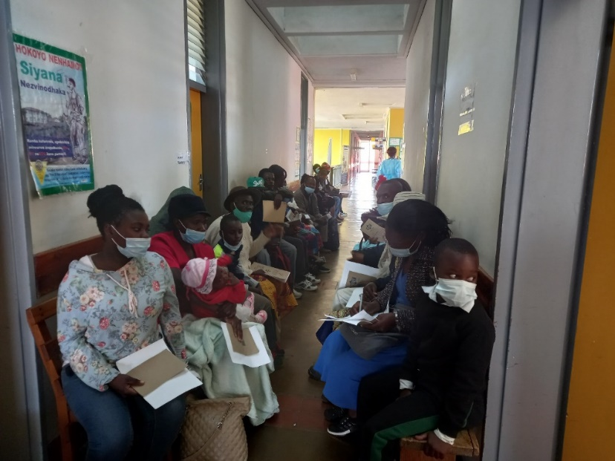

**Photo 2**. Client undergoing audiological test during Chipinge Ear Camp

**Photo 3**. Mr Temba Moses from Victoria Chitepo Provincial Hospital ear syringing a client

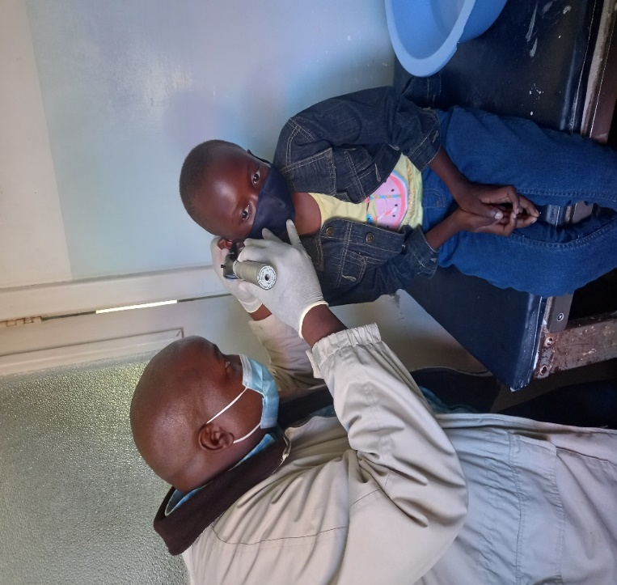

**Photo 4**. Ear and Hearing Training of stakeholders and Community Health Workers during Chipinge Ear Camp

**Photo 5**: ENT Equipment in the recently completed Paediatric ENT Theatre at Sally Mugabe Children’s Hospital.

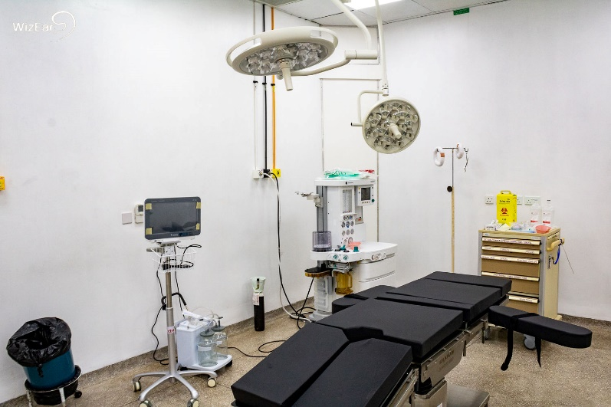

**Photo 6:** Recovery Beds in the paediatric ENT Theatre at Sally Mugabe Hospital.

**Photo 7:** Deputy Director Rehabilitation Department Handing over ENT equipment and consumables at Mpilo Central Hospital.

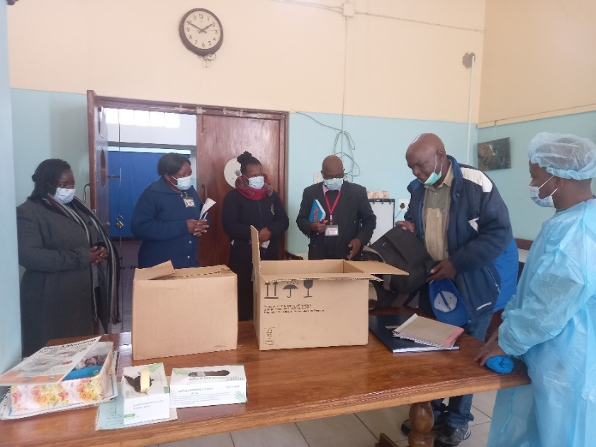

1. **Comments from responsible CBM Office**

The project started the year on a positive note with project implementation on track. The theatre handover was delayed due to late arrival of some of the imported equipment and availability of Public Works Department to conduct the overall assessment and give the go ahead to proceed with the handover. The theatre was eventually opened in October and all the 4 Fridays of the month were dedicated to conducting surgeries which boosted the number of surgeries conducted to 1.227 from 192 previously achieved in 2021. The error that occurred on the CBM finance reporting tool gave a false balance of EUR446 000 as the total balance at CBM for the project including funds carried over from previous years. Expenditure rate was increased in Q2 to try and use up the funds. It was later established end of Q3 that the reported balance had not been correct and as a result, the partner had already overspent the allocated budget for the year. This greatly affected project implementation in Q3 and Q4. However, the CBM team and partner are currently working on finding a solution to this matter and the partner got approval to utilise the reserve budget, which was supposed to have been called up by December 2021.